BCIS 4610, Fall 2016
HW #5

Part 1. ERD to relational DB model.

- Translate the ER diagram below into a relational DB model.
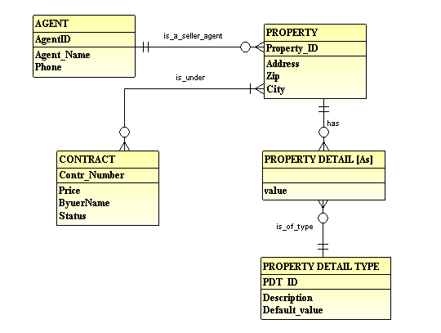

Show the relational tables in the following format:
TABLE_NAME (Attr1_PK, Attr2, …, AttrN, Attr_FK1, Attr_FK2)

- Based on your solution in section A, create tables and relationships in MS Access. You will need to make appropriate decisions about data types. You will need to submit your Access Files as a part of the assignment.

Part 2. Normalization
Problem A
Assume the following dependencies:
PO# Date
PO_Item# PO_Item_Descr
PO_Item# PO_Item_Price

PURCHASE_ORDER (PO# and PO_Item# is the composite primary key).
PO# | Date | PO_item# | PO_Item_Descr | Po_Item_Price

What is the Normal form of the above relation?
__________NF

Why?

How would you bring the above relation to the 3 NF? List final 3NF relations.

Problem B
Assume the following dependencies:
Contr# Date
Contr# Buyer_ID
Buyer_ID Buyer_name

CONTRACT (Contr# is the primary key)
Contr# | Date | Buyer_ID | Buyer_name

What is the Normal form of the above relation?
__________NF

Why?

How would you bring the above relation to the 3 NF? List final 3NF relations.

